**PROJECT REPORT ON TECHPRO SOLUTION (INFORMATION TECHNOLGY-INDUSTRY)**

**1. INTRODUCTION:**

1.1 OVERVIEW:

My project name is techpro solution (information technology-industry)

We combine cutting-edge technologies with strategic expertise to help customers meet their business needs.

We utilize the latest technology to provide sophisticated and secure IT solutions using an effective delivery model to ensure flexibility and agility.

1.2 PURPOSE:

We utilize the latest technology to provide sophisticated and secure IT solutions using an effective delivery model to ensure flexibility and agility.

Our specialty of operations includes Application Lifecycle Management, Infrastructure Lifecycle Management and Product Lifecycle Management.

TechPro IT Solutions, A leading Web Design Company & Digital Marketing Agency with unmatched capabilities & diverse background of building strategic, customizable and insight-driven solutions that maximize Business efficiency & Best ROI.

**2. PROBLEM DEFINITION & DESIGN THINKING:**

2.1 EMPATHY MAP

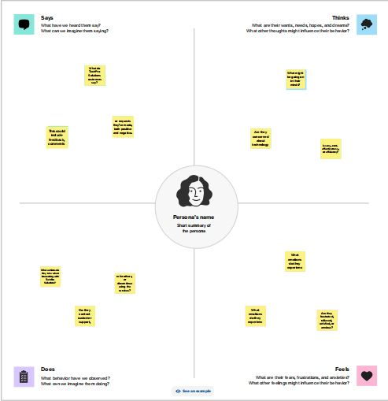

2.2 IDEATION & BRAINSTORMING MAP

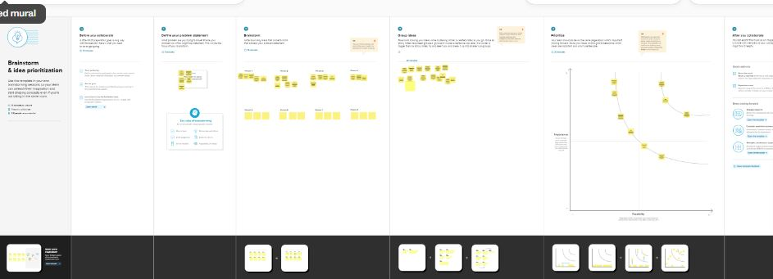

**RESULT:**

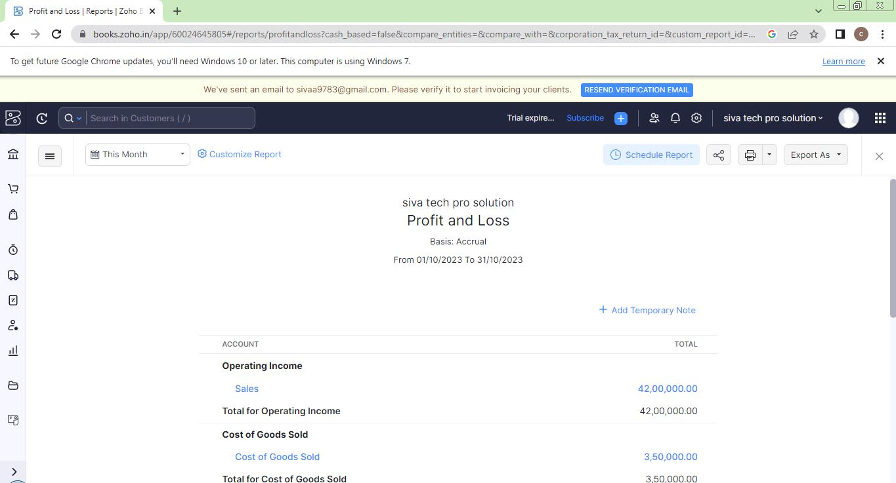

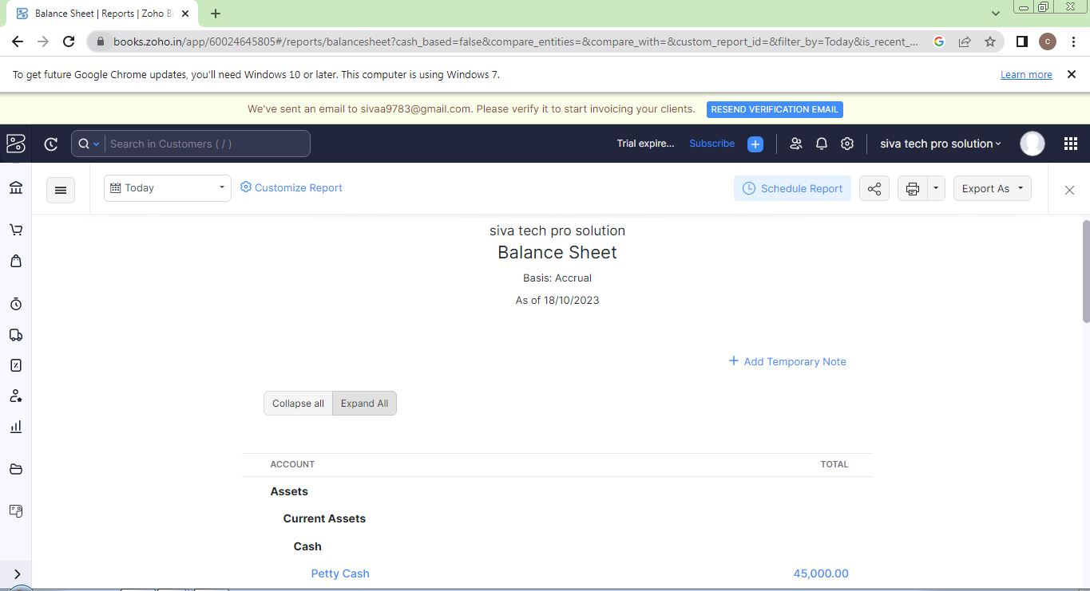

**4. ADVANTAGES & DISADVANTAGES:**

ADVANTAGES:

We combine cutting-edge technologies with strategic expertise to help customers meet their business needs. We utilize the latest technology to provide sophisticated and secure IT solutions using an effective delivery model to ensure flexibility and agility. Our specialty of operations includes Application Lifecycle Management, Infrastructure Lifecycle Management and Product Lifecycle Management. Our “High performance business” strategy builds on our expertise in consulting, technology and outsourcing to help clients perform at the highest levels so that they can create sustainable value for their customers and shareholders.

DISADVANTAGES:

Though a wireless network may seem like the solution to all your problems, you should beware of security issues that come with it. A wireless network works by transmitting data over the air. It is, therefore, more prone to data leak than a wired network.

Hackers often target people who use wireless networks. Though security is a serious problem with wireless networks, you can combat this by using different encryption technologies. Using an encryption system can prevent you from cyber-attacks.

**5. APPLICATIONS**

**GIT HUB AND ZOHO BOOKS** are used to applied the solution.

**6. CONCLUSION:**

we identify new business and technology trends and develop solutions to help clients across the globe.

For our clients, we offer a flexible and supportive work environment that focuses on the needs and career development goals of its people; while always focusing on delivering the highest quality.

**7. FUTURE SCOPE:**

new developments in artificial intelligence, we'll be able to easily search, analyze, and handle massive volumes of data.

Yet, the future of information technology will have an influence on more than just our personal lives. The environment around us will change as well.